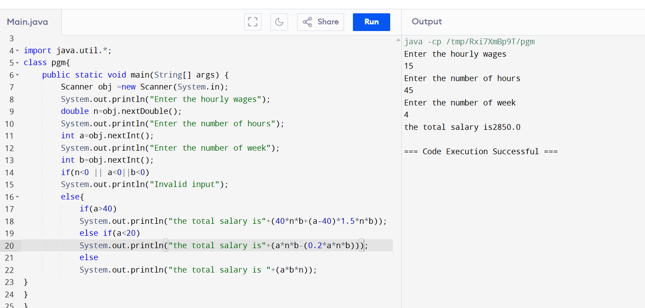

import java.util.\*;

public class pgm{

public static void main(String args[]){

Scanner obj=new Scanner(System.in);

System.out.println("enter the number");

int b=obj.nextInt();

int c;

c=b;

int rem,rev;

int max=c%10;

int min=c%10;

while(c!=0){

rem=c%10;

if(rem>max){

max=rem;

}

else if(rem<min){

min=rem;

}

c=c/10;

}

System.out.println(max);

System.out.println(min);

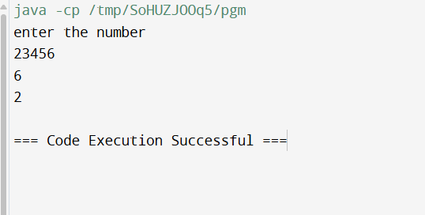

2.import java.util.\*;

public class pgm{

public static void main(String args[]){

Scanner obj=new Scanner(System.in);

System.out.println("enter");

String type=obj.next();

System.out.println("enter the number of tickets ");

double total;

int num=obj.nextInt();

if(type.equals("regular")){

total=num\*50;

if(total<200){

total=total+20;

}

if(num>10){

total=total-(total\*0.10);

}

System.out.println(total);

}

else if(type.equals("vip")){

total=num\*100;

if(total<200){

total=total+20;

}

if(num>5){

total=total-(total\*0.15);

}

System.out.println(total);

}

else if(type.equals("preminum")){

total=num\*150;

if(total<200){

total=total+20;

}

if(num>3){

total=total-(total\*0.20);

}

System.out.println(total);

}

}

}

